How can I use the school printers?

For Students
DON’T FORGET YOU WILL ONLY BE ABLE TO PRINT IF YOU ARE CONNECTED TO STUDENTS WIFI
The printers in the school have a touch login screen. To login, you need to use a 5-digit code that was sent to your school email. To retrieve your code, please open your mailbox and search for an email with the subject “Your Printing Code Has Changed”
Instructions to install the printer on Windows computers:
If you have a Mac, then scroll down to the Mac section below.
First, connect your Windows or Mac laptop to the Wi-Fi with the name SGI-Students use the following password if requested “SG-$tud3nts!” without the “” of course!
- Click the link to download this file pc-print-deploy-client[10.2.249.4].msi
- Once the download is completed, open the file. You should see this Windows: 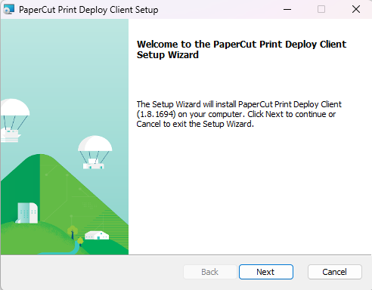
- Click on Next and wait for the program to finish the installation. Once the Setup is completed then click on Finish.
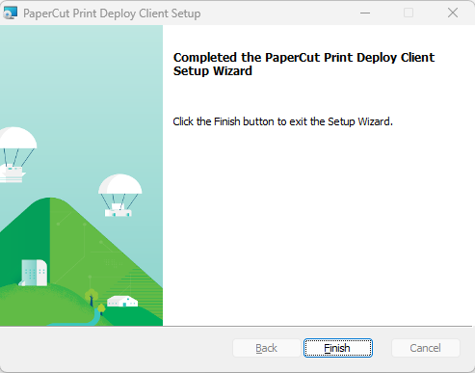

- A few seconds later, you will see a Windows like below asking for your Username and Password. If the same Windows opens two times, then just close one and use the other to fill in the data.
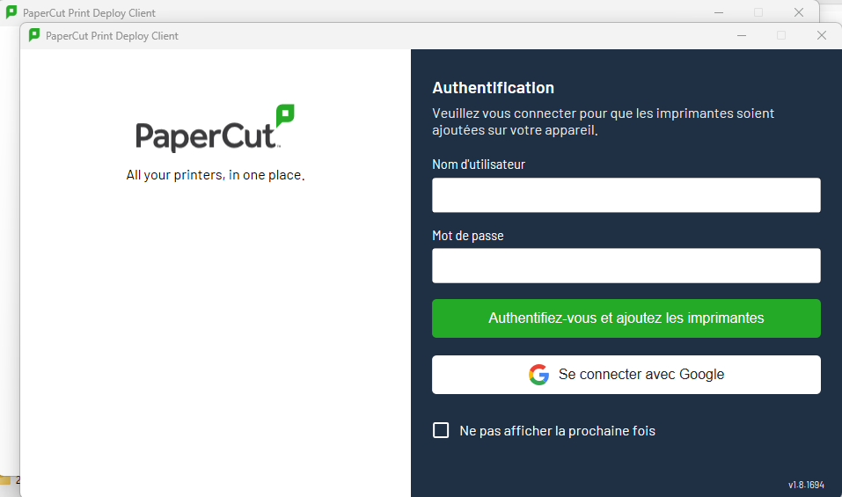
- On the first field type your school email address (...@stgeorges.ch) and then the password below. Now click on the long green button -Login and add the printers-.
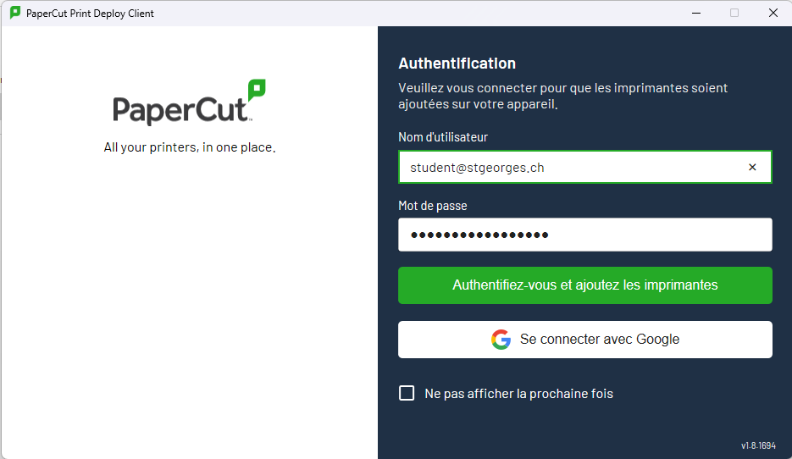
- Once you are successfully logged in, you will see a Windows like the one below loading the printers. When the printer installation is completed, you will see a green banner below with the notification.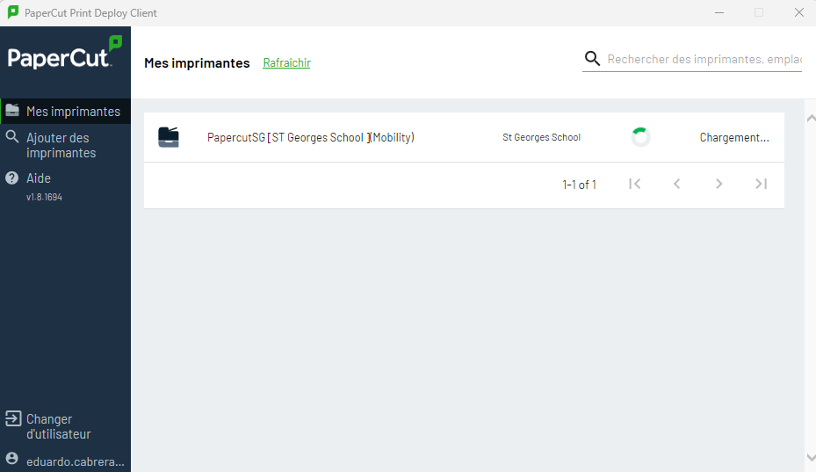

- Great! You can now start using the printers from your laptop. Open a document in Microsoft Word, then go to File > Print and please always check the printer named Papercut SG [St Georges School] (Mobility) is selected. Then just click on print.
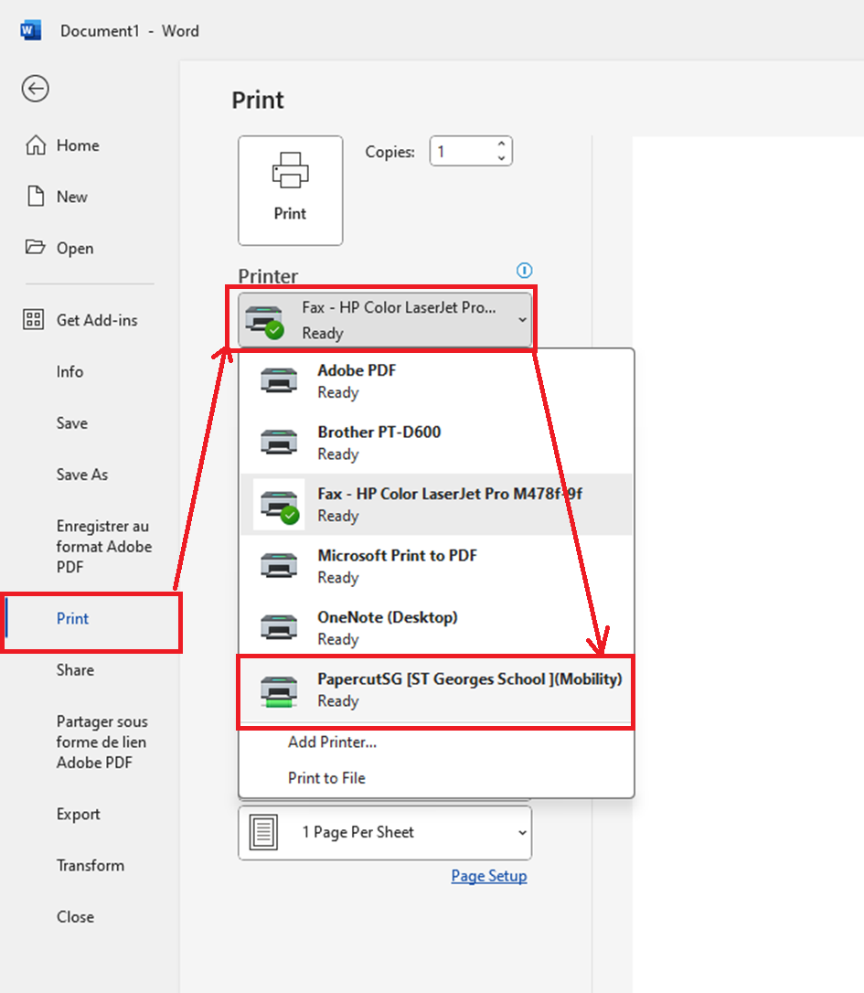

Instructions to install the printer on Mac computers:
First, connect your Windows or Mac laptop to the Wi-Fi with the name SGI-Students use the following password if requested “SG-$tud3nts!” without the “” of course!
- Click this link to download the DMG file pc-print-deploy-client[10.2.249.4].dmg
- Once the download is completed, run the file. You should see this Windows. Execute the package file to start the installation.
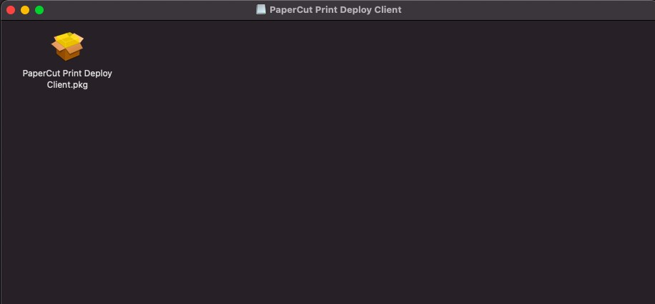
- You will see a Windows like the one below. Please click Continue and proceed with the installation. Type your password or use your fingerprint if requested in the following steps.
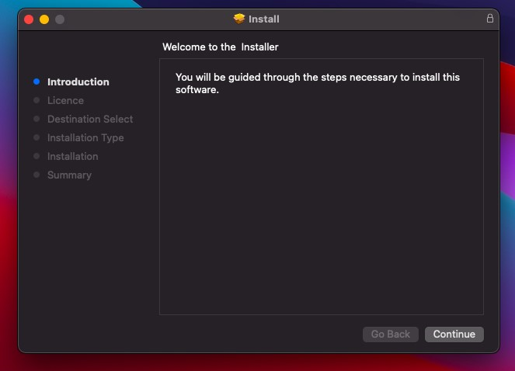

- During the setup you will be asked if the installation can make changes on your computer. Please click OK so that the printer drivers can be installed.
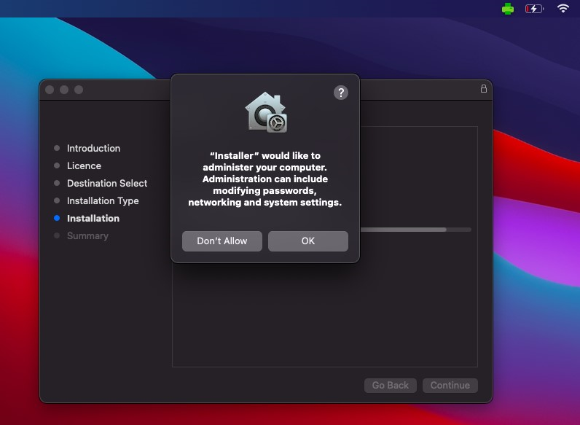
- You should see the following screen once the setup is completed. Please note that the print agent should now be running on your top bar. Check if you can see the green printer icon as highlighted on the image. Please click Close on the Installation Wizard
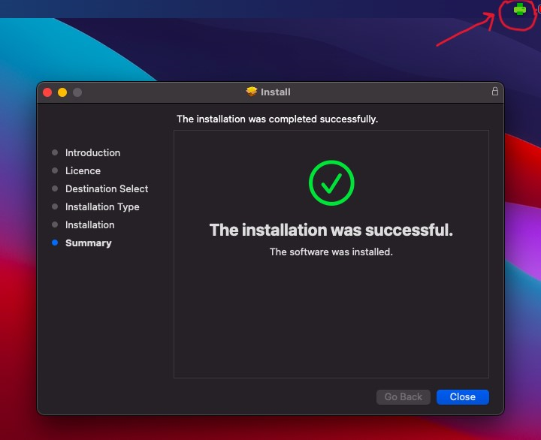

- Once you click Close you will see the authentication Windows. Please type your school email address (...@stgeorges.ch) and then the password below. Now click on the long green button -Login and add the printers-.
- Once you are successfully logged in, you will see Windows like the one below loading the printer. When the printer installation is completed, you will see a notification on your desktop. Please close this Windows when the printer installation is finished.

- Great! You can now start using the printers from your laptop. Open a document in Microsoft Word, then go to File > Print and please always check the printer named Papercut SG is selected. Then just click on print.

